Challenge 3: You need to select more then one value in Master Dashboard and then click on Right Arrow then it should navigate to Detail Dashboard.
Detail Dashboard should filter according to Master Dashboard selection.

for any reference go to this link through :
http://www.tableauexpert.co.in/2016/01/do-you-feel-that-you-are-tableau-expert.html

1. connect superstore data source
2. In sheet 1 , Drag region into rows and category into cols and sales in text shelf
3. In sheet 2, create a cal field Arrow with empty double quotes like " "
=>drag into text shelf
=>in marks shelf , select shapes as arrows
4. In sheet 3, drag category, subcategory into rows and region into cols and sales in text shelf
5. Create a dashboard named as Master Dashboard

=>drag sheet 1 and 2 into dasboard

6. Create another dashboard named as Detail Dashboard

=>drag sheet 3 into dasboard

7. Goto Master Dashboard, from Dashborad menu select Actions

=>select Addaction
=>select source
=>Master Dashboard :sheet1
=>select Target
=>Master Dashboard : sheet2
=>select : selection icon

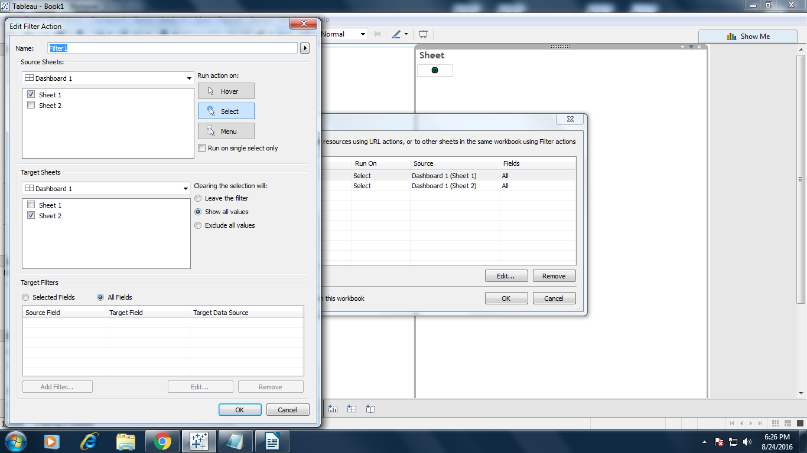

8. Again create one more dashboard action like

=>select Addaction
=>select source
=>Master Dashboard :sheet2
=>select Target
=>Detail Dashboard : sheet3
=>select : selection icon

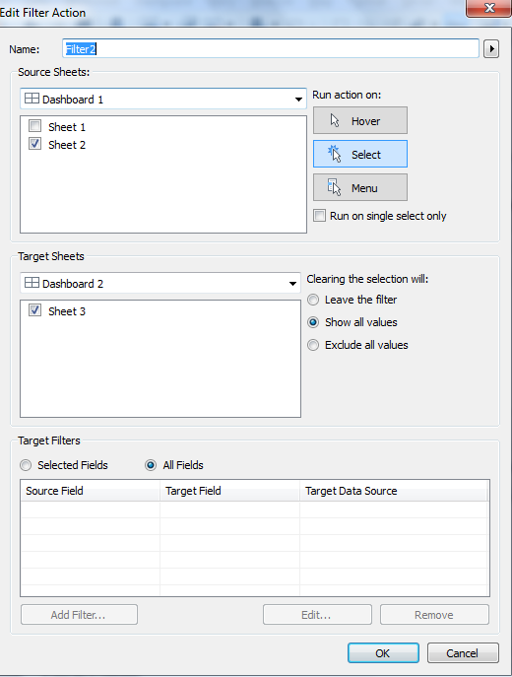

9. Now we select data from master dashboard and click on arrow it goto detail dashboard but data not filter because when we apply actions on sheets, all actions are moved to filter shelf of respective sheets.

10. Go to sheet2 => filter shelf => drill down => apply to work sheets => selected work sheets => sheet3.

11. Now it gives the data after filter apply.

Challenge 6 : I need the customers who made 1 order , 2 orders, 3 orders so on and how many number of orders were returned by them.

For any reference go to this link through :
http://www.tableauexpert.co.in/2016/02/do-you-feel-that-you-are-tableau-expert_29.html

1. Create a cal field named as count of orders.

{ FIXED [Customer Name] : COUNTD([Order ID])}

2. Convert the cal field count of orders into dimensions.

3. Drag count of orders into cols and sales into rows.

4. Create another cal field named as returns.

{ FIXED [Customer Name] : COUNTD([Order ID (Returns)])}

5. Convert the cal field returns into dimensions.

6. Drag returns into color shelf and arrange the colors manually or ascending order.

7.Goto sum(sales) =>quick table calculation => Percent of total

8. Goto sum(sales) =>computing using => Cell

9. Now it display desired result.

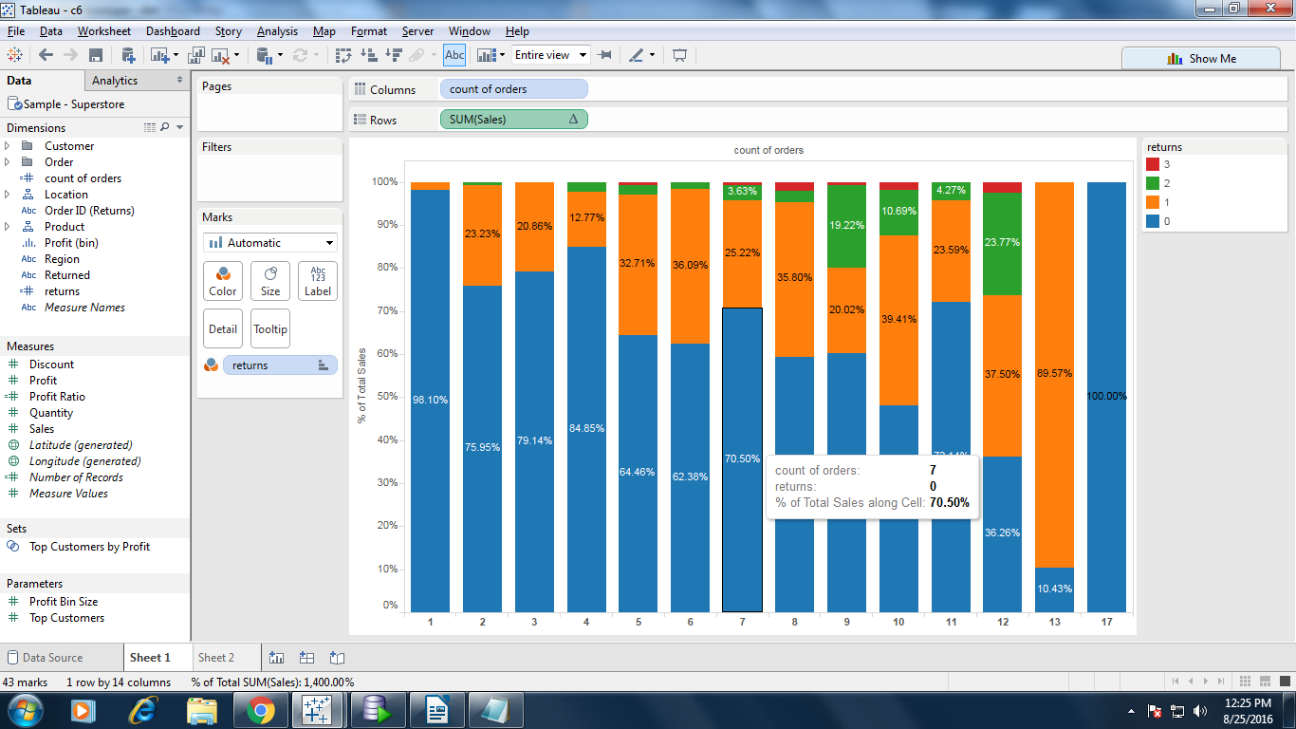

Challenge 9: I am showing report with category and Sum(Sales). User will select Dimension name from the “select dimension parameter”. Based on user selection, in next filter the values of that dimension will show.

For any reference go though this link
http://www.tableauexpert.co.in/2016/08/do-you-feel-that-you-are-tableau-expert.html

1. Create a parameter Selection Dimension(Parameters)

Datatype: Stinrg
Allowable values : list
Region
Segment
Top 5 products by sales

2. Create a set on product name based top 5 sales named as Top 5 product by sales

3. Create a calculated field named as Top 5 product names like

if [Top 5 product by sales] then [Product Name] else "others" END

4. Create a calculated field named as filter calculation like

if [selection dimension]="Region" then [Region]
ELSEIF [selection dimension]="Segment" then [Segment]
ELSEIF [selection dimension]="Top 5 products by sales" then [Top 5 product names]
END

5. Drag the category dimension into columns and sales measures into rows

6. Show the parameter contol of selection Dimenesion(Paramters)

7. Drag the filter calculation dimension into filtershelf

8. Show the show filter of filter calculation

9. Create a cal field like true/false

isnull([filter calculation])

10. Drag true/false dimension into filter shelf select false

10. Right the filter calcalculation show select the only revelant values

11. It display the desired while selecting selection dimension(parameters).

Challenge 8: I am showing New Customers, Retention Customers and % of Retention for each Segment.

For any reference go though this link :
http://www.tableauexpert.co.in/2016/07/do-you-feel-that-you-are-tableau-expert.html

Steps:
1. Create a set New customers count

COUNTD(if YEAR([first order]) =INT([year]) then [Customer Name] END)==1

2. Create one more set for All Customers with RG

COUNTD(if YEAR([Order Date]) =INT([year])+INT([Retention gap]) then [Customer Name] END)==1

3. Now create a combined set for Retention Customers Count

All customers with RG intersection New Customers count

4. Now create a measure to show the New Customers

COUNTD(if [New customers count] then [Customer Name] END)

5. Again create a measure to show the Retention Customers

COUNTD(if [Retention Customers count] then [Customer Name] END)

6. create a cal field %Retention

([Retention customers]/[New Customers])*100

7.Create a Parameter Named has Year

Datatype : String
List: 2011, 12, 13, 14

8. Create a one more parameter named has Retention Gap

Datatype : String
List: 1, 2

9. Show the parameter controls of Year, Retention Gap

10. Drag Segment into columns

11. Drag Measure Values into rows and select New Customers, Retention Customers, %Retention.
12. Drag Measure Names into Columns in ascending order and Color shelf.

13. It display the desired while selecting Year, Retention Gap Paramters.

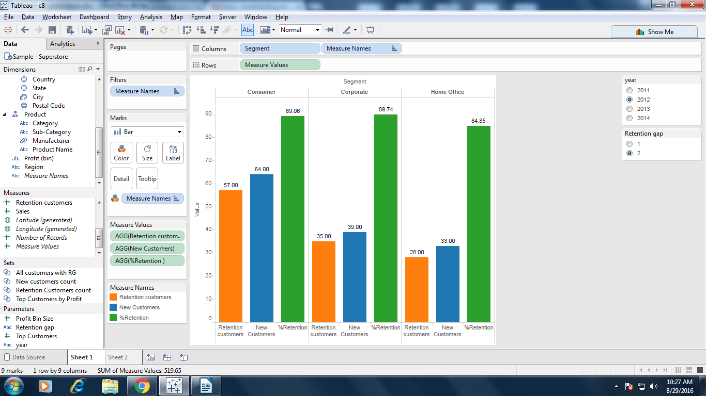

Challenge 10:

Steps:

1. Open a new workbook and connect to the dimension source.

2. Create a claculate field named as handling_null

case [Gap]
when null then [Value] end

3. Create a another calculate field named as distance

if SUM([Value])>SUM([Gap])
then FLOAT(SUM([Gap]))
else FLOAT(SUM([Value]))
END

4. From dimension pane , drag dimension field into column shelf.

5. From measures pane, drag value and handling_null into row shelf.

6. From marks card, expand the value and select gant bar chart.

7. Again expand the handling_null and select the bar graph.

8. Now drag dimension field into color of ALL marks card.

9. Drag the gap field into size and text mark of value card.

10. Drag the distnace field into text mark of handling_null card.

11. Now it show's the desired result of challenge 10.

Date Functions:

Tableau provides a variety of date functions.

1. DATEADD(date_part, interval, date)

Returns the specified date with the specified number interval added to the specified date_part of that date.

Ex: DATEADD('month', 3, #2004-04-15#)
DATEADD('day', 3, #2004-04-15#)
DATEADD('year', 3, #2004-04-15#)
DATEADD('hour', 3, #2004-04-15#)
DATEADD('minute', 3, #2004-04-15#)
DATEADD('second', 3, #2004-04-15#)

2. DATEDIFF(date_part,date1,date2,[start_of_week])

Returns the difference between date1and date2 expressed in units of date_part.
Ex: DATEDIFF('week', #2016-08-25#, #2016-08-30#) =1 week difference between the dates
DATEDIFF('day', #2016-08-25#, #2016-08-30#)
DATEDIFF('month', #2016-08-25#, #2016-10-30#)
DATEDIFF('year', #2016-08-25#, #2017-10-30#)
DATEDIFF('quarter', #2016-08-25#, #2017-10-30#)
DATEDIFF('hour', #2016-08-25#, #2017-10-30#)

3. DATENAME(date_part,date,[start_of_week])

Returns date_part of date as a string. The start_of_week parameter is optional.

Ex: DATENAME('year', #2016-08-25#) 2016
DATENAME('month', #2016-08-25#) August
DATENAME('day', #2016-08-25#) 25
DATENAME('quarter', #2016-08-25#) 3
DATENAME('dayofyear', #2016-08-25#) 238
DATENAME('weekday', #2016-08-25#) Thursday
DATENAME('week', #2016-08-25#) 35
DATENAME('hour', #2016-08-25#) 0

4. DATEPARSE(format,string)

Converts a string to a datetime in the specified format.

Ex: DATEPARSE ("dd.MMMM.yyyy", "25.August.2016") 8/25/2016 12:00:00 AM
DATEPARSE ("h'h' m'm' s's'", "10h 5m 3s")

5. DATEPART(date_part, date, [start_of_week])
Returns date_part of date as an integer.
Note: When the date_part is weekday, the start_of_week parameter is ignored. This is because Tableau relies on a fixed weekday ordering to apply offsets.

Ex: DATEPART('year', #2016-08-25#) 2016
DATEPART('quarter', #2016-08-25#) 3
DATEPART('weekday', #2016-08-25#) 5
DATEPART('hour', #2016-08-25#) 0

6. DATETRUNC(date_part, date, [start_of_week])
Truncates the specified date to the accuracy specified by the date_part. This function returns a new date. For example, when you truncate a date that is in the middle of the month at the month level, this function returns the first day of the month. The start_of_week parameter is optional. If it is omitted, the start of week is determined by the data source.

Ex: DATETRUNC('month', #2016-08-25#) 8/1/2016 12:00:00 AM
DATETRUNC('quarter', #2016-08-25#) 7/1/2016 12:00:00 AM
DATETRUNC('week', #2016-08-25#) 8/21/2016 12:00:00 AM

7. DAY(date)
Returns the day of the given date as an integer.
Ex: DAY(#2016-08-25#) 25

8. ISDATE(string)
Returns true if a given string is a valid date.
Ex: ISDATE("August 25, 2016") true

9. MAKEDATE(year, month, day)
Returns a date value constructed from the specified year, month, and date.
Ex: MAKEDATE(2016, 8, 25) 8/25/2016

10. MAKEDATETIME(date,time)
Returns a datetime that combines a date and a time. The date can be a date, datetime, or a string type. The time must be a datetime. This function is available only for MySQL connections.

Ex: MAKEDATETIME("1899-12-30", #07:59:00#) 12/30/1899 7:59:00 AM
MAKEDATETIME([Date], [Time]) 1/1/2001 6:00:00 AM

11. MONTH(date)
Returns the month of the given date as an integer.
Ex: MONTH(#2004-04-15#) 4

12. NOW( )
Returns the current date and time.
The return varies depending on the nature of the connection

Ex: NOW( ) = 2004-04-15 1:08:21 PM

13. TODAY( )
Returns the current date.

Ex: TODAY( ) 2016-08-25

